1. All plots/graphs should have suitable title, labels, axis scaling and (legends if any).
2. **Upload the Matlab .m script file and .slx Simulink file for the task given below.**
3. Name the files of lab session 6 as L6_201#A#PS####G.m and L6_201#A#PS####G.slx

Task -Design a bandstop filter with a cut-off frequency of 8000 Hz and 16000 Hz.

Sampling freq is 48000 Hz.

Use hamming window of length 37. (Generate the impulse response h(n) using fir1 function in your code.)

Input signal is combination of 3 sinusoids, 5000Hz, 12000 Hz, and 20000 Hz. (Magnitude 1 v for all the frequencies).

Output should be presented as follows:

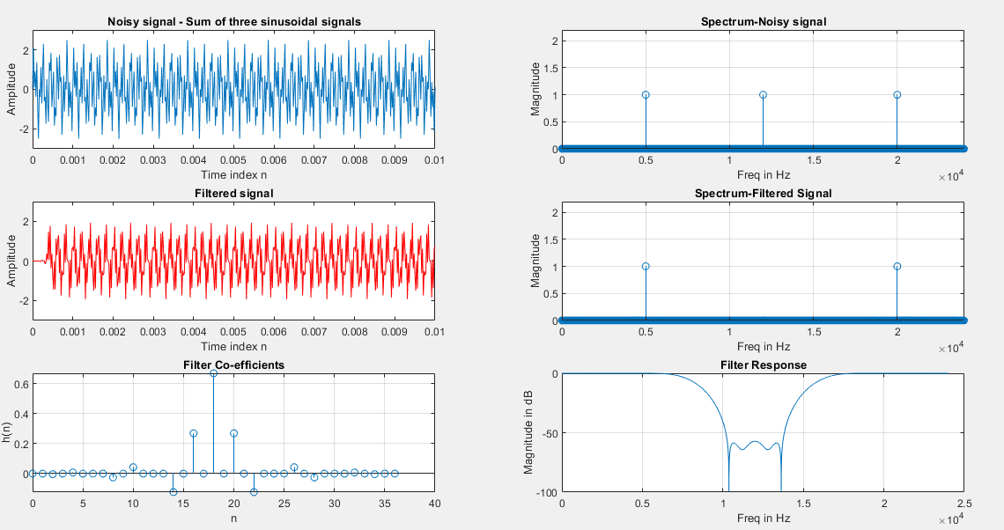

Also, export the filter as model in Simulink. Show the filtering effect in the Simulink for same set of input frequencies. You can use a scope with 3 input ports to show time-domain view of a) noisy signal, b) filtered signal (digital domain), and c) filtered signal (analog domain). You can also show the output in frequency domain using Spectrum Analyzer. (Use the sampling rate as “inherited” in Spectrum analyzer for the correct result.) Show the input and output in frequency domain using spectrum analyzer.

Note –

For time-domain view – run simulation for very small time period.

For spectrum view, run the simulation for longer time period.